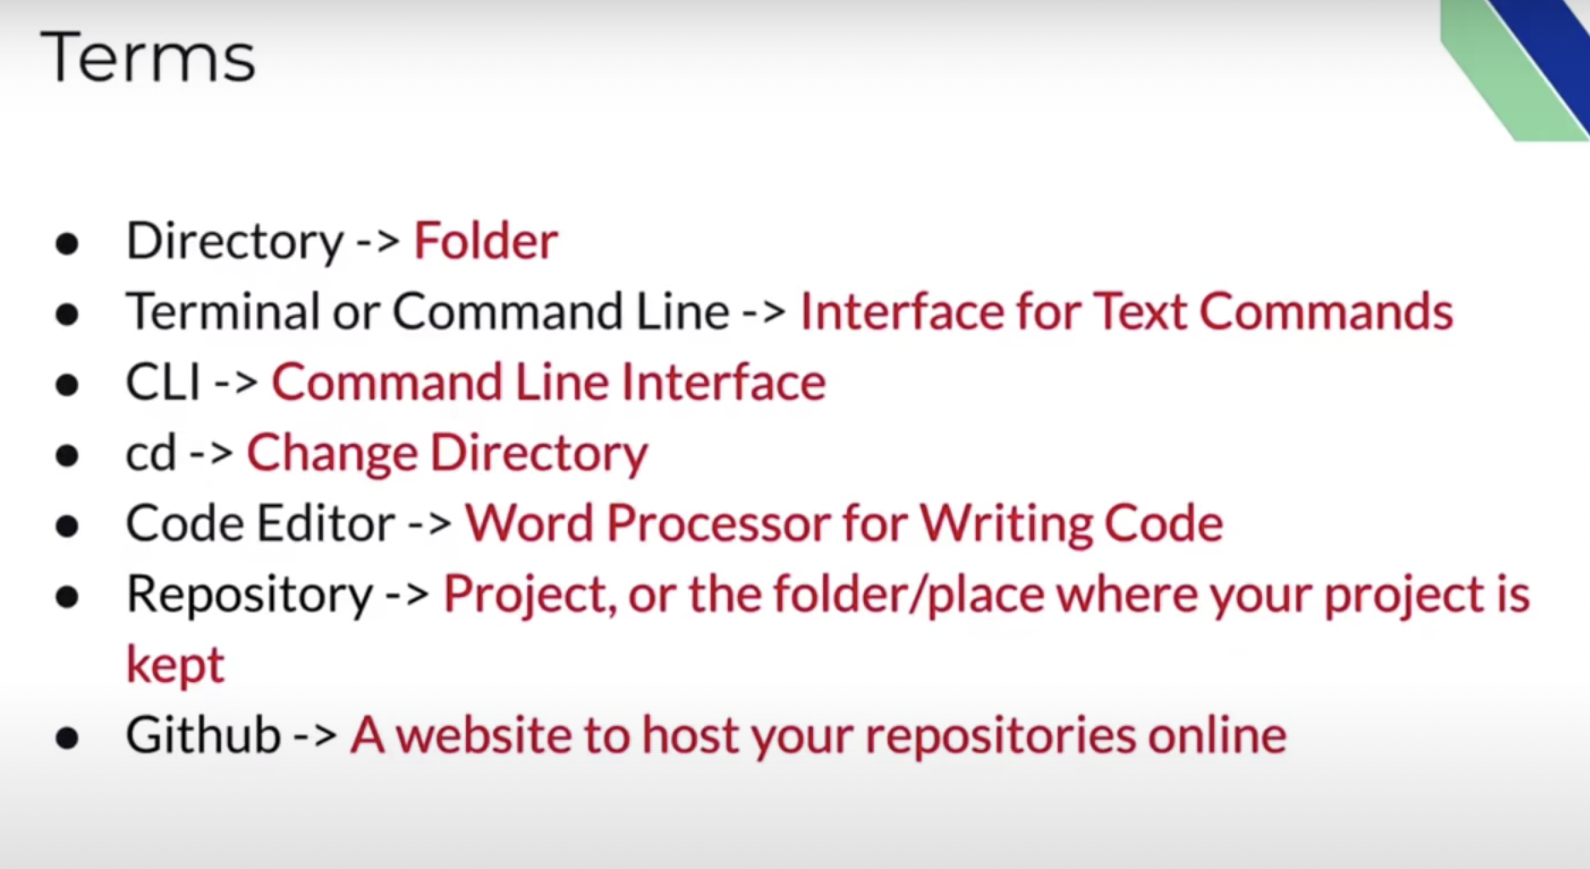

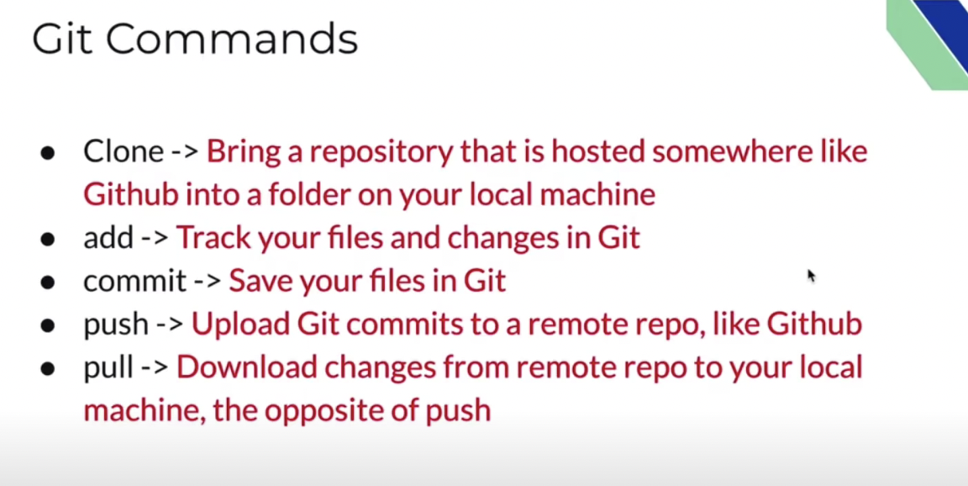

Create repo and readme.md (Mark Down) # for title and save

**Git clone** in vs code terminal with git ssh link

Edit

**Git status**

**Git add .** (To add all the new files)

Git add index.html ( to add specific file to git)

**Git commit -m “” (Message) -m “” (description)**

**Git push origin main**